**ASSIGNMENT-4(AP)**

**Name:** Yashvardhan Singh

**UID:** 22BCS10258

**Section:** 22BCS_FL_IOT-604

**Group:** A

1763.[Longest Nice Substring](https://leetcode.com/problems/longest-nice-substring/description/)

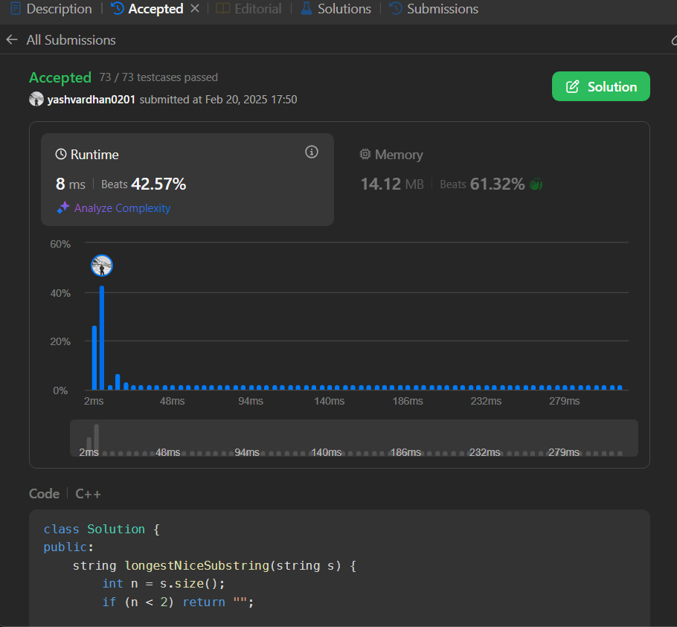

190.[Reverse Bits](https://leetcode.com/problems/reverse-bits/description/)

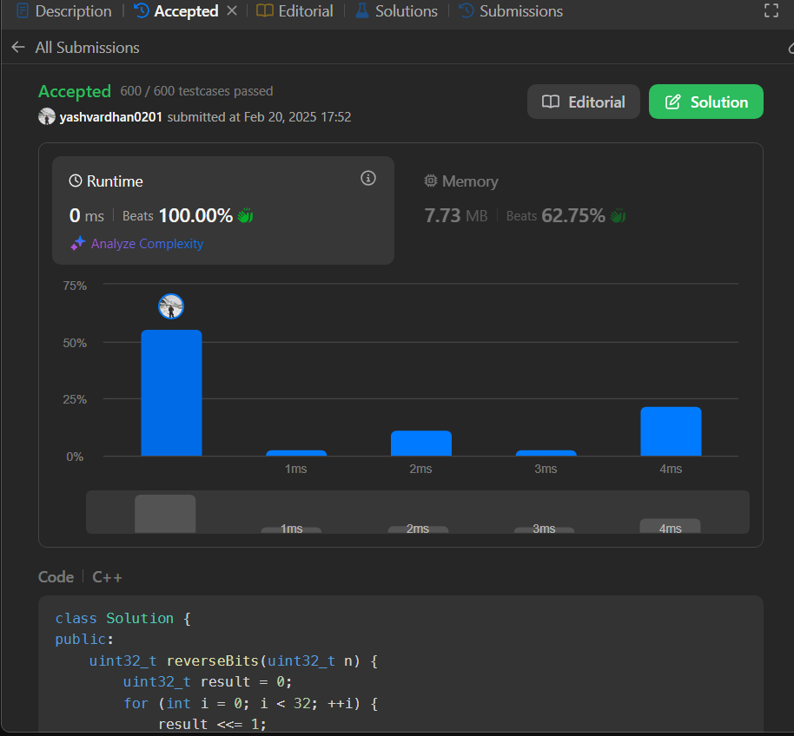  
191.[Number of 1 Bits](https://leetcode.com/problems/number-of-1-bits/description/)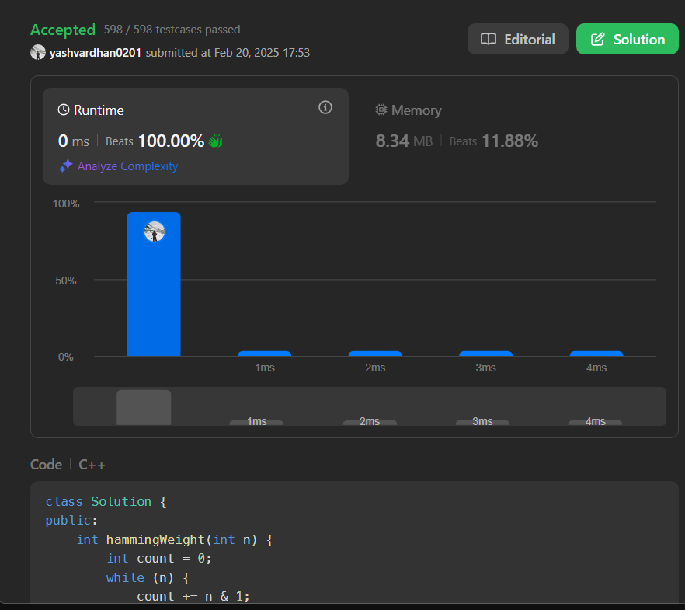

53.[Maximum Subarray](https://leetcode.com/problems/maximum-subarray/description/)

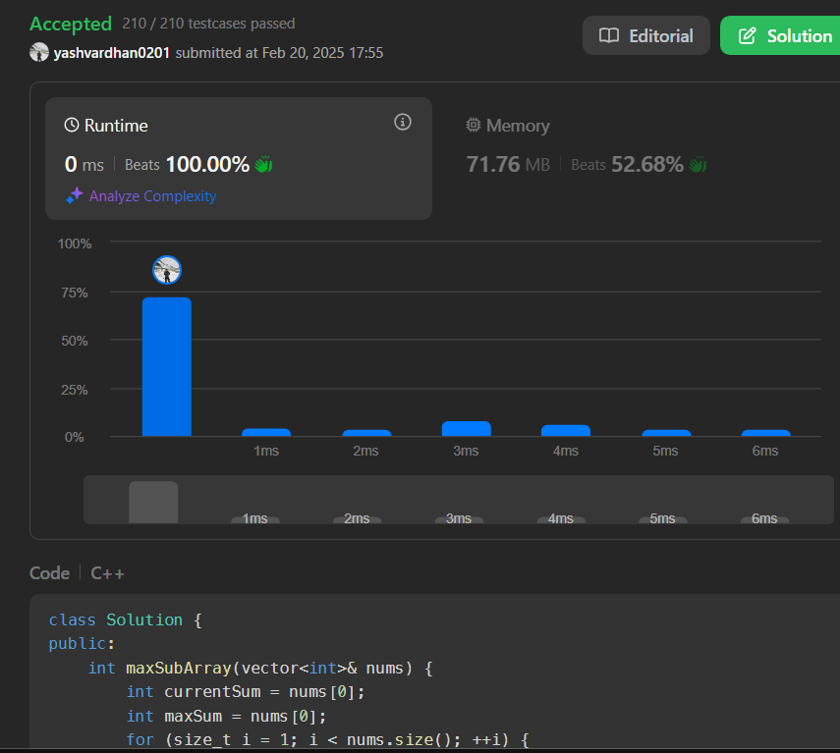  
240.[Search a 2D Matrix II](https://leetcode.com/problems/search-a-2d-matrix-ii/description/)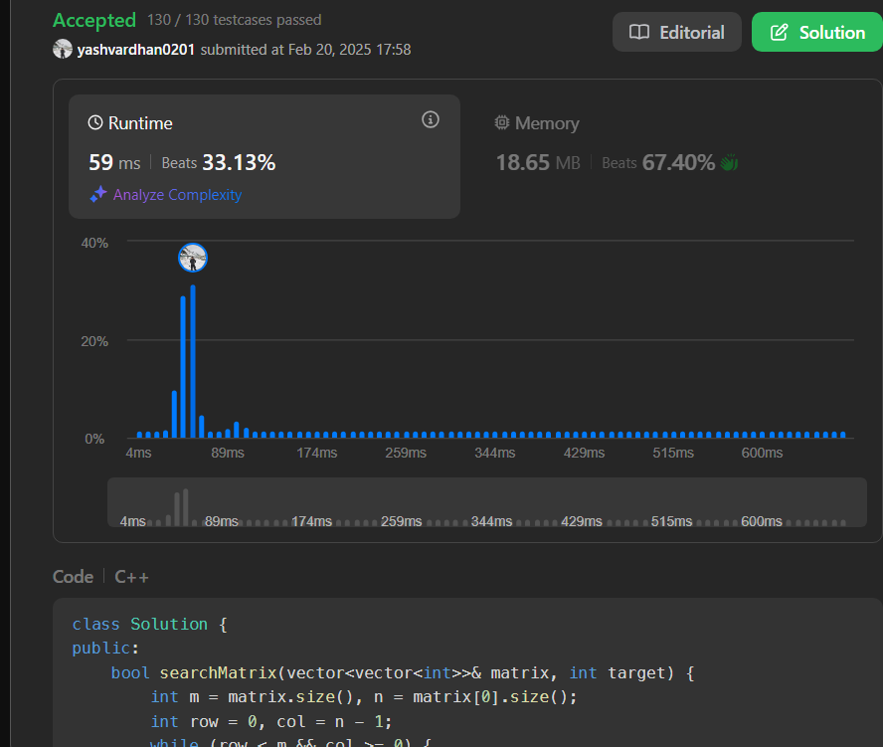

372.[Super Pow](https://leetcode.com/problems/super-pow/description/)

